THE DAY OF PENTECOST

May 23/26, 2021 A.D. Rev. Dr. Cory J. Rajek – (608) 359-2646

Faith Ev. Lutheran Church – Pierre, SD Senior Pastor

Website: www.faithluth.com Rev. Sam Handschke – (314) 489-9181

Email: faith@faithluth.com Associate Pastor

Church Phone – (605) 224-2216 Church Fax – (605) 224-2226

A Christ Caring People Who Gather Around Word and Sacrament,

Yoked Together, In Personal Service to Christ in World Wide Missions

T DIVINE SERVICE T

OPENING HYMN “Come Thou Almighty King” (LSB 905)

INVOCATION
P In the name of the Father and of the T Son and of the Holy Spirit.
C Amen.

GODSPEED TO OUR MEXICO MISSION TEAM MEMBERS (11:00A)

Exhortation
P Beloved in the Lord! Let us draw near with a true heart and confess our sins unto God our Father, beseeching Him in the name of our Lord Jesus Christ to grant us forgiveness.

P Our help is in the name of the Lord,
C who made heaven and earth.
P I said, I will confess my transgressions unto the Lord,
C and You forgave the iniquity of my sin.

CONFESSION and ABSOLUTION
P O almighty God, merciful Father,
C I, a poor, miserable sinner, confess unto You all my sins and iniquities with which I have ever offended You and justly deserved Your temporal and eternal punishment. But I am heartily sorry for them and sincerely repent of them, and I pray You of Your boundless mercy and for the sake of the holy, innocent, bitter sufferings and death of Your beloved Son, Jesus Christ, to be gracious and merciful to me, a poor, sinful being.
P Upon this your confession, I, by virtue of my office, as a called and ordained servant of the Word, announce the grace of God unto all of you, and in the stead and by the command of my Lord Jesus Christ I forgive you all your sins in the name of the Father and of the T Son and of the Holy Spirit.
C Amen.

T WORD T

INTROIT Psalm 104:24,27-28,30 (antiphon: liturgical text)
P Come, Holy Spirit, fill the hearts of your faithful,
and kindle in them the fire of your love. Alleluia!
C O LORD, how manifold are your works! In wisdom you have made them all;
the earth is full of your creatures.
P These all look to you,
to give them their food in due season.
C When you give it to them, they gather it up;
when you open your hand, they are filled with good things.
P When you send forth your Spirit, they are created,
and you renew the face of the ground.
C Glory be to the Father and to the Son and to the Holy Spirit;
as it was in the beginning, is now, and will be forever. Amen.
P Come, Holy Spirit, fill the hearts of your faithful,
and kindle in them the fire of your love. Alleluia!

Kyrie
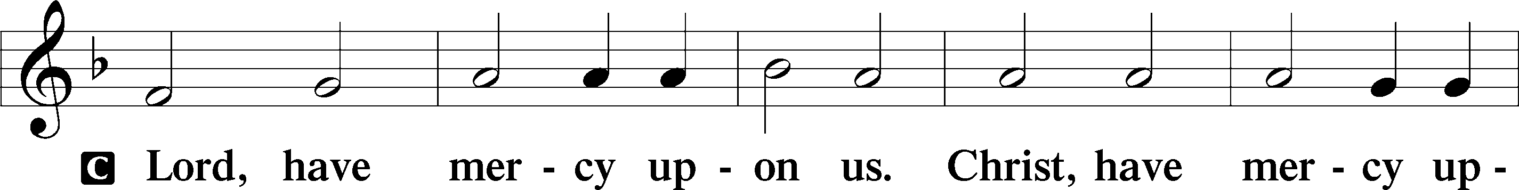
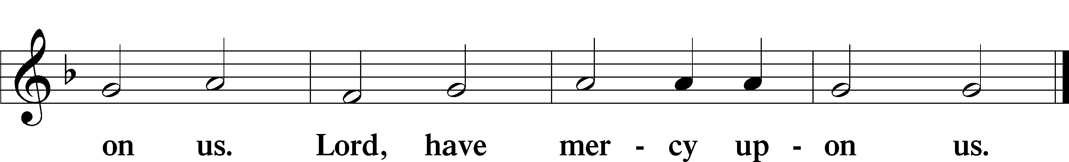

GLORIA in Excelsis
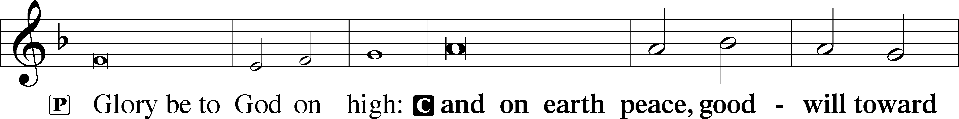
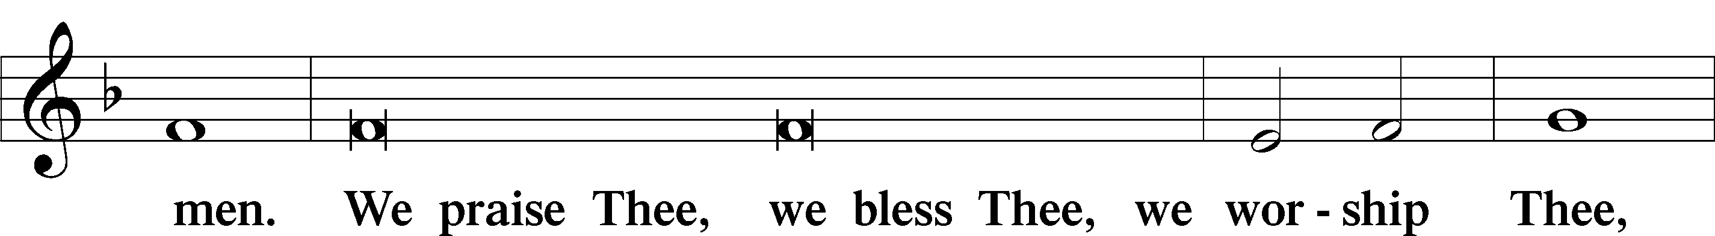
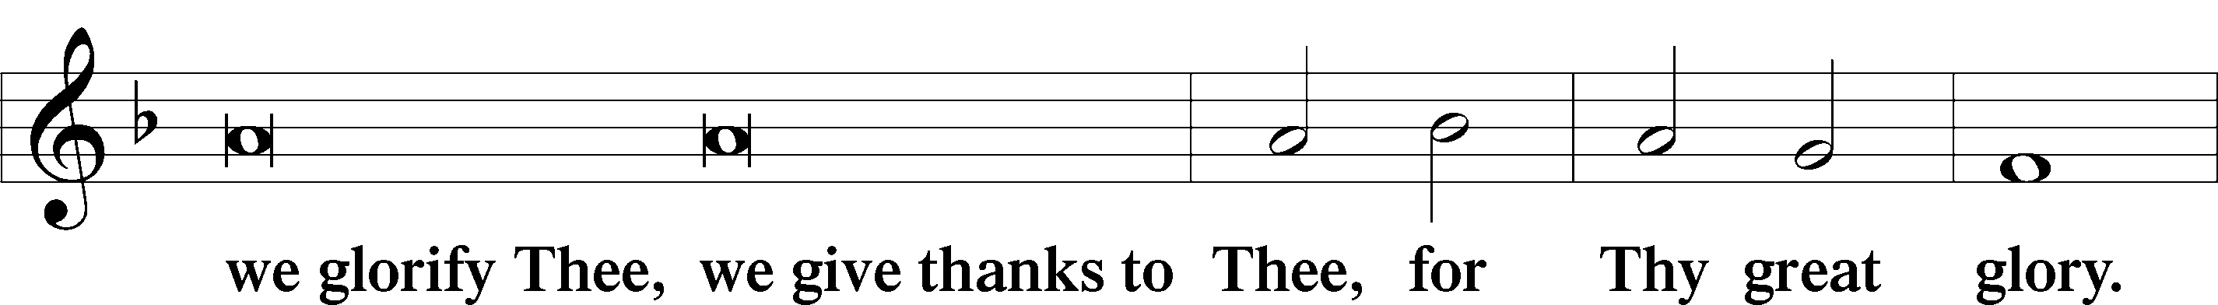
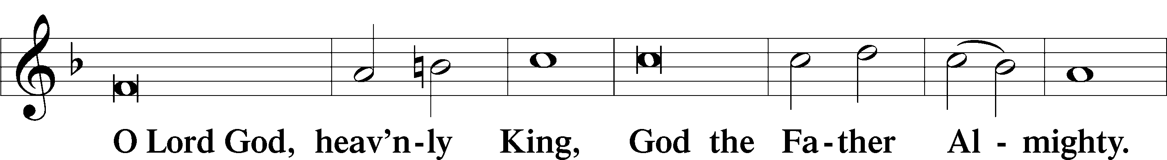
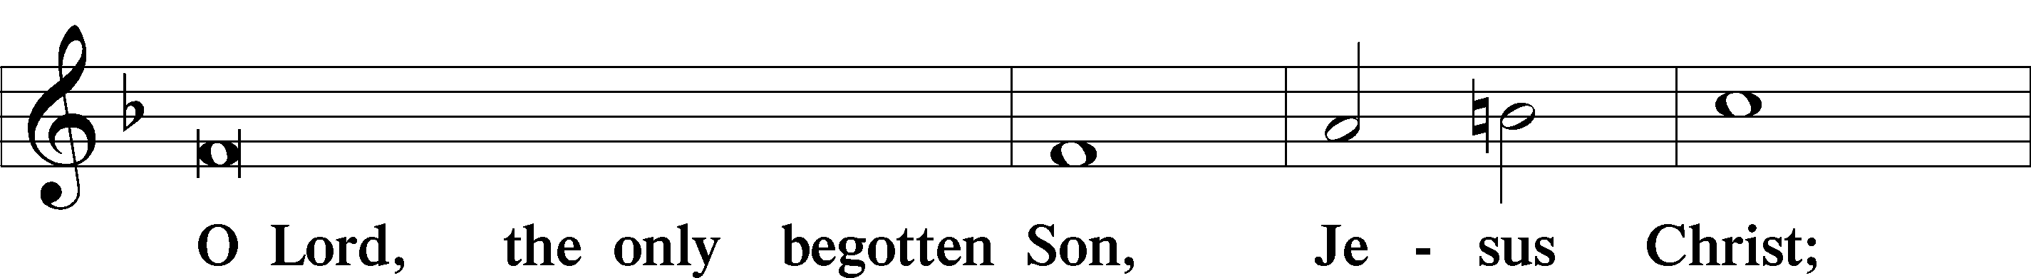
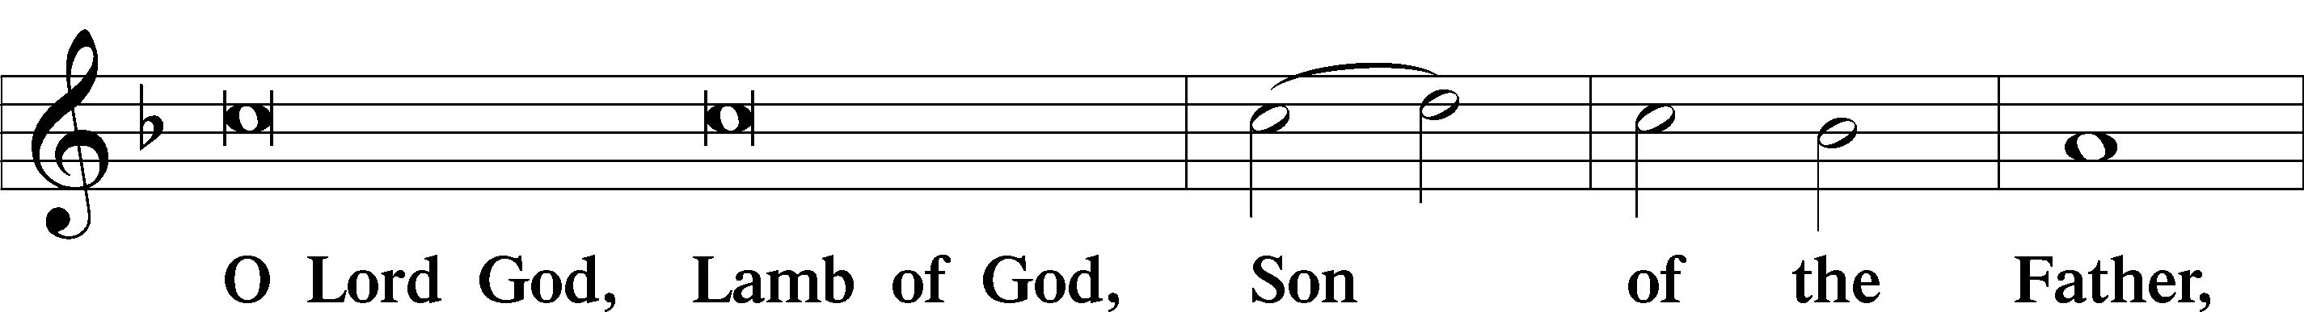
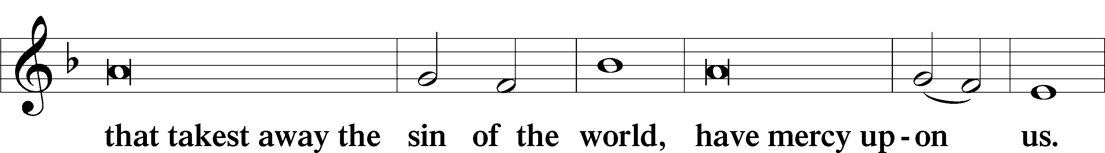
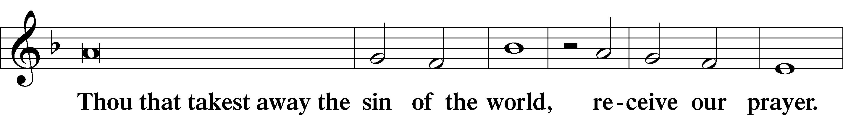
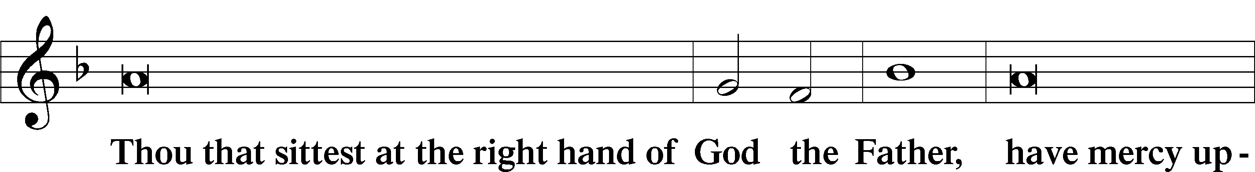
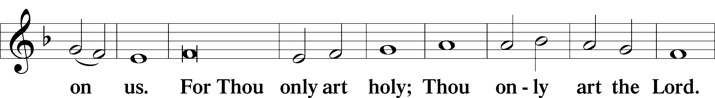
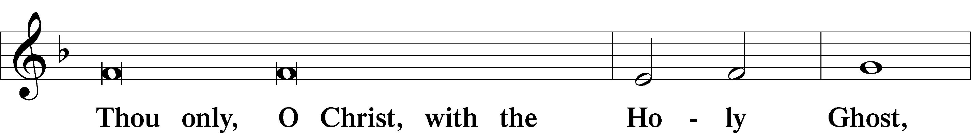
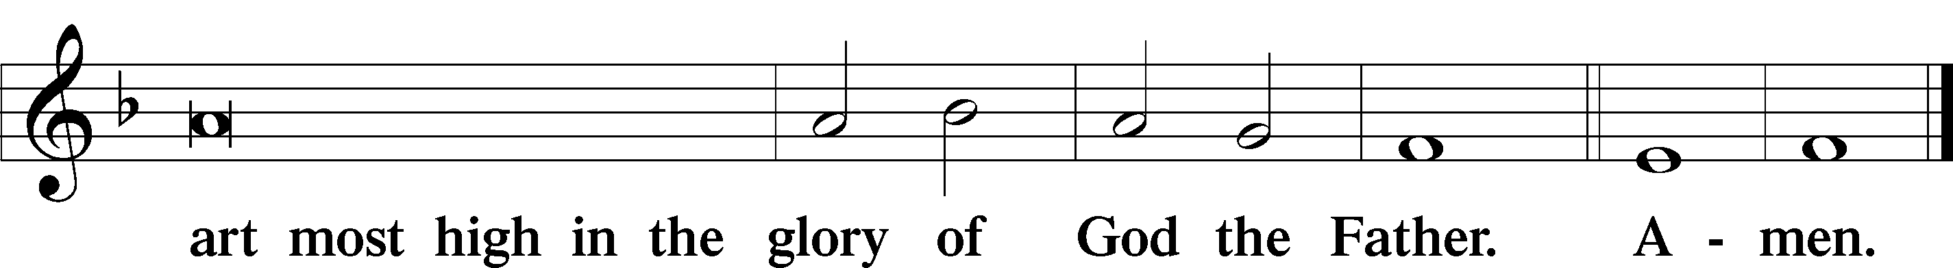
Salutation and Collect of the Day
P The Lord be with you.
C And also with you.
P Let us pray. O God, on this day You once taught the hearts of Your faithful people by sending them the light of Your Holy Spirit. Grant us in our day by the same Spirit to have a right understanding in all things and evermore to rejoice in his holy consolation; through Jesus Christ, Your Son, our Lord, who lives and reigns with You and the Holy Spirit, one God, now and forever.
C Amen.

(Please be seated)

OLD TESTAMENT Ezekiel 37:1-14 (The Lord will open the graves)

After the reading:
L This is the Word of the Lord.
C Thanks be to God.

ANTHEM “How Majestic Is Your Name” (Smith, arr. Raney)
Moriah Gross, violin

SECOND READING Acts 2:1-21 (The message of Jesus in all languages)

After the reading:
L This is the Word of the Lord.
C Thanks be to God.

(Please stand)

Alleluia
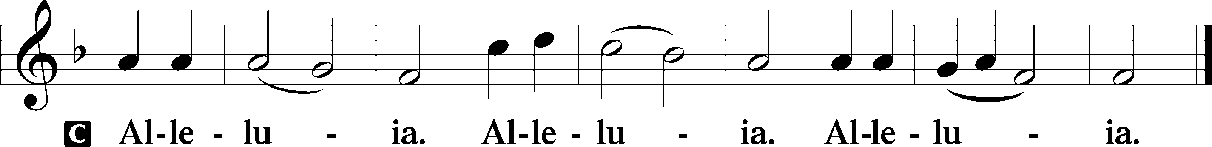

HOLY GOSPEL John 15:26-27; 16:4b-15 (Jesus promises the Holy Spirit)
P The Holy Gospel according to St. John, the fifteenth and sixteenth chapters.
C Glory to You, O Lord.

After the reading:
P This is the Gospel of the Lord.
C Praise to You, O Christ.

(Please be seated)
BIBLE LESSON – PETER PREACHES ABOUT JESUS (PAGE 360)

SERMON HYMN “Holy Spirit, Ever Dwelling” (LSB 650)

SERMON “God At Work” (Acts 2:1-21)
Pastor Cory J. Rajek

CREED 8:30 am/7:00 pm Apostles’ Inside back cover of the Lutheran Service Book
11:00 am Nicene Inside back cover of the Lutheran Service Book

OFFERING We gather our tithes, gifts of love, and our “Building Together in Faith” gifts.

(Please stand)

GODSPEED TO OUR HIGH SCHOOL GRADUATES (8:30A)

Nathan Haberling
Lane Hedglin
Ajaye Hicks
Jacob Larson
Elliot Leif
Dayna Martinmaas
Molly Neyhart
Jayden Nickerson
Kaylie Rathbun
Shelby Roman
Hannah Schochenmaier
Christopher Schultz
Michael VanDeWiele

PRAYERS OF THE CHURCH
P In peace, let us pray to the Lord:
C Lord, have mercy.

P For the Holy Church established on the proclamation of Christ, that His Spirit would sustain the apostolic preaching to the ends of the earth, especially thanking him for the ministries of _____________ and that in every tongue the mighty works of God would be heard, let us pray to the Lord.
C Lord, have mercy.

P For hope in the midst of this world of death and despair; that God would put His Spirit within us to believe, to live and to serve according to His promises and commands; and that He would lead our homes to confess confidence in His power to raise the dead — now and at the Last Day, let us pray to the Lord.
C Lord, have mercy.

P For our high school graduates, that the Lord would continue to lead and guide them into the calling that he has prepared for them, and that they would be blessed with opportunities to grow in love towards God and in service towards one another, let us pray to the Lord:
C Lord, have mercy.

P For the members of our Mexico mission team, that the Lord would grant them safe travel to every destination, that he would bless and prosper the spreading of his precious gospel, and that he would imbue them with strength and encouragement in both body and mind, let us pray to the Lord:
C Lord, have mercy.

P For the help and salvation of all especially _____________; that the Spirit would renew the face of the earth, look with favor on His creatures and fill the hearts of the faithful, kindling in them the fire of His love, let us pray to the Lord.
C Lord, have mercy.

P Into Your hands, O Lord, we commend all for whom we pray, trusting in Your mercy through Jesus Christ, our Lord.
C Amen.

LORD’S PRAYER
C Our Father who art in heaven, hallowed be Thy name, Thy kingdom come,
Thy will be done on earth as it is in heaven; give us this day our daily bread;
and forgive us our trespasses as we forgive those who trespass against us;
and lead us not into temptation but deliver us from evil. For Thine is the kingdom and the power and the glory forever and ever. Amen.

The 8:30am/7:00pm services continue on page 10 with the Benediction.

IN REGARD TO HOLY COMMUNION: According to Scripture, Holy Communion should be celebrated by those who are: United in a common faith (1 Cor. 10:16-17, 21-22; Rom. 16:17); Repentant of sins (1 Cor. 5:11, Matt. 18:17-18); Able to examine their lives (1 Cor. 11:27-29); and believe that in this precious meal they receive the true body and blood of Jesus given and shed for the forgiveness of their sins (Luke 22:19-22).
Since Scripture teaches that those people who do not fully understand the meaning of this meal eat and drink to their own harm (1Cor. 11:27-29), and because the Lord’s Supper is the supreme act of stating our unity in faith and doctrine, we would ask those people who are visiting with us to please speak with one of our pastors, before communing, in order that we might fulfill our responsibility of properly instructing people in the right use of the precious Sacrament.

T SERVICE OF THE SACRAMENT T
11:00 am

Preface
P The Lord be with you.
C And with thy spirit.
P Lift up your hearts.
C We lift them up unto the Lord.
P Let us give thanks unto the Lord our God.
C It is meet and right so to do.
P It is truly meet, right, and salutary that we should at all times and in all places give thanks to You, holy Lord, almighty Father, everlasting God, through Jesus Christ, our Lord, who ascended above the heavens and, sitting at Your right hand, poured out on this day the promised Holy Spirit on His chosen disciples. For all this the whole earth rejoices with exceeding joy. Therefore, with angels and archangels and with all the company of heaven we laud and magnify Your glorious name, evermore praising You and saying:

Sanctus
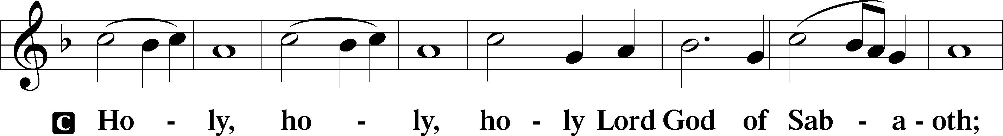
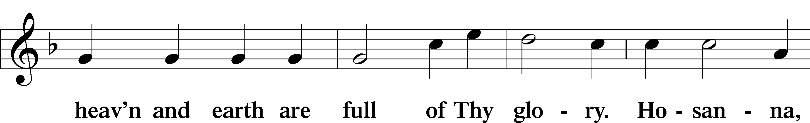
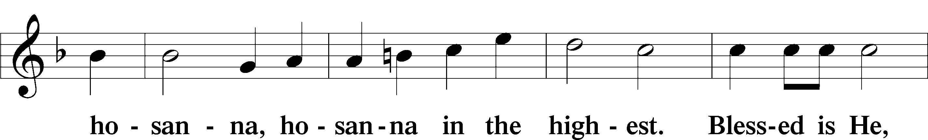
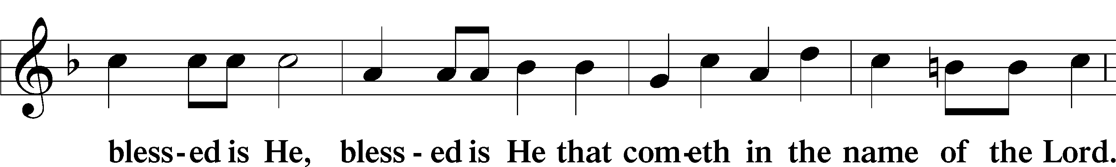
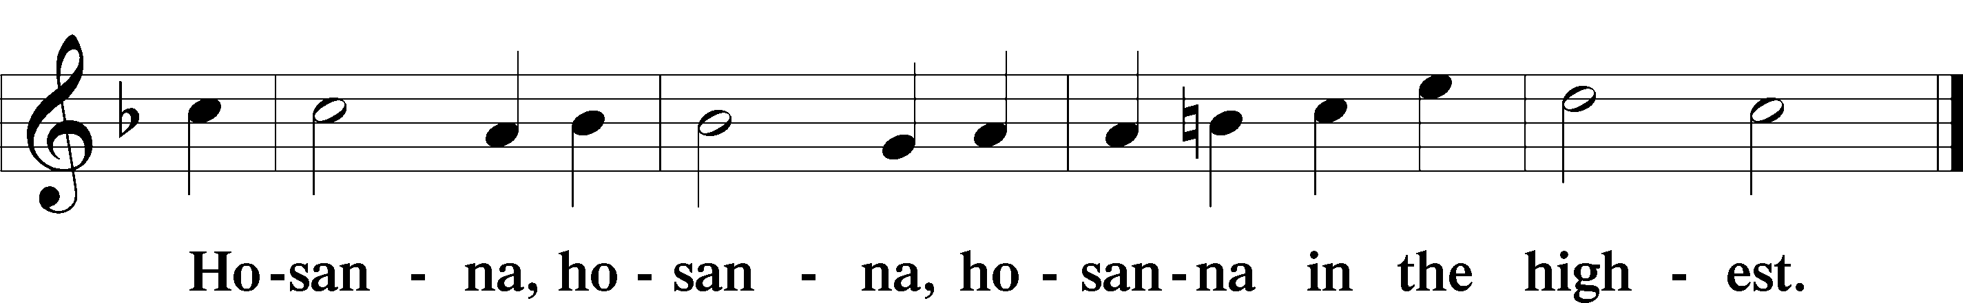

WORDS OF OUR LORD Matt 26:26–28; Mk 14:22–24; Lk 22:19–20; 1 Cor 11:23–25

PAX DOMINI
P The peace of the Lord be with you always.
C And also with you.

Agnus Dei
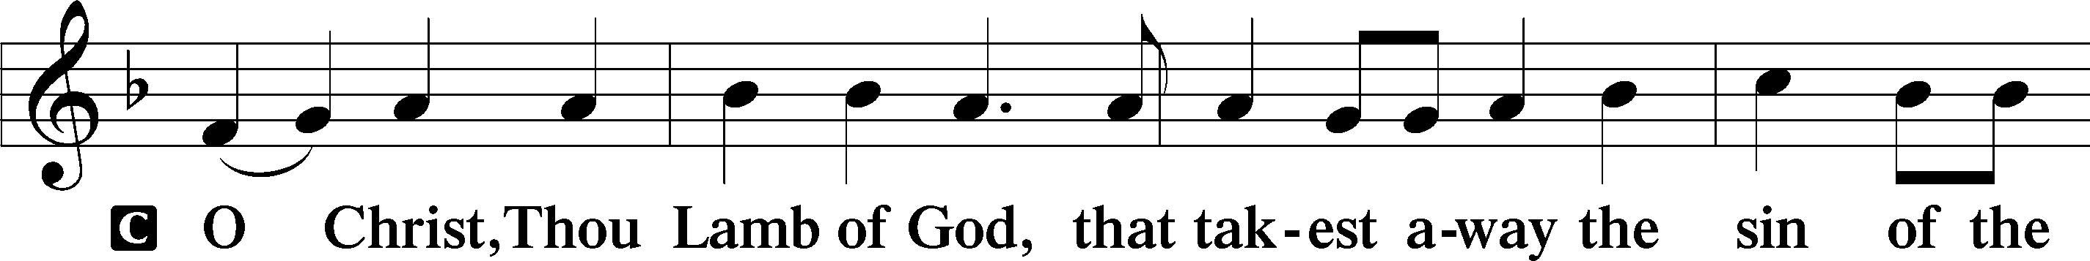
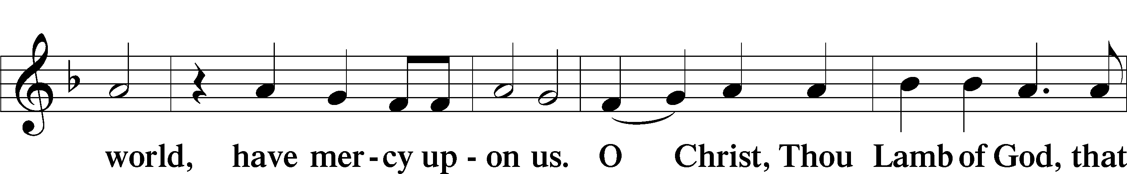
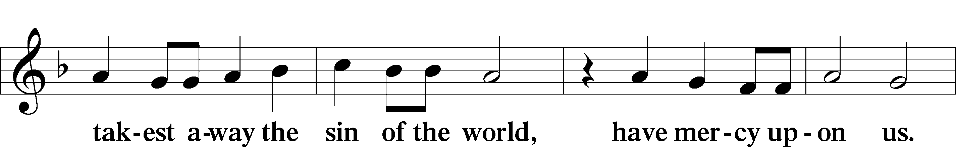
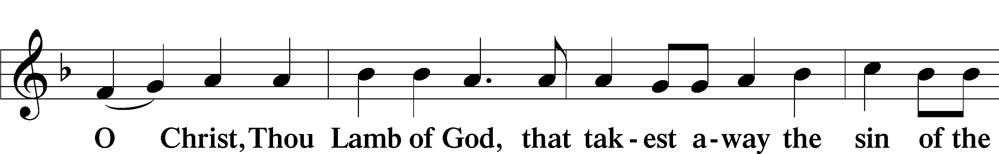

(Please be seated)

DISTRIBUTION HYMNS
“Holy Spirit, Light Divine” (LSB 496)
“Draw Near and Take the Body of the Lord” (LSB 637)

DISMISSAL OF COMMUNICANTS

(Please stand)

NUNC DIMITTIS
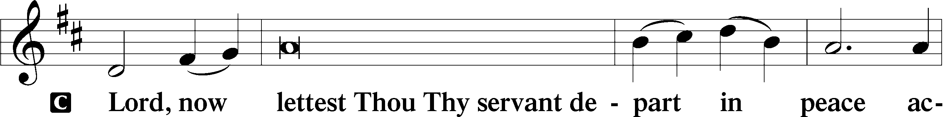
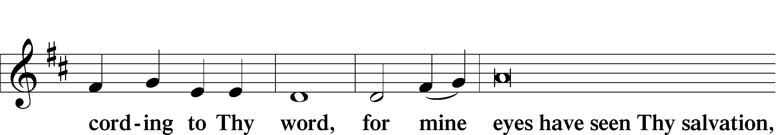
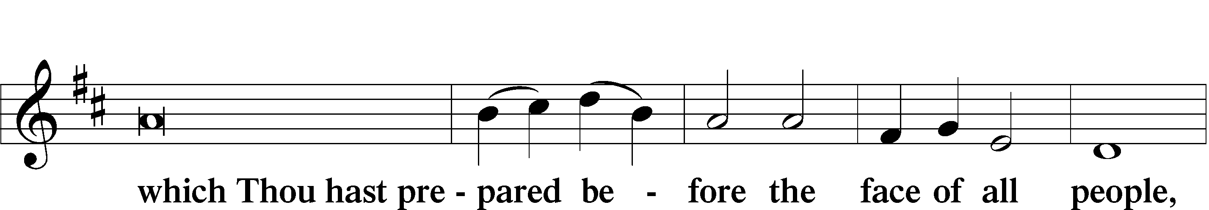
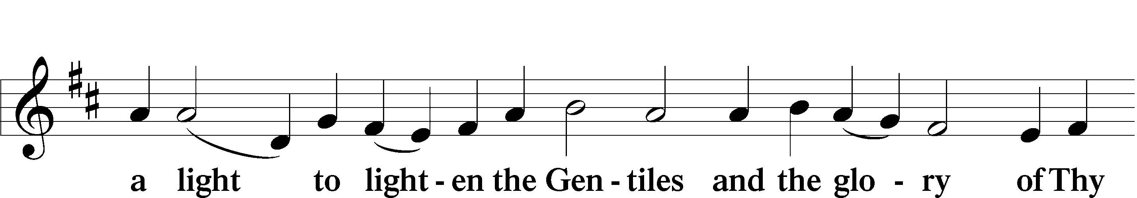
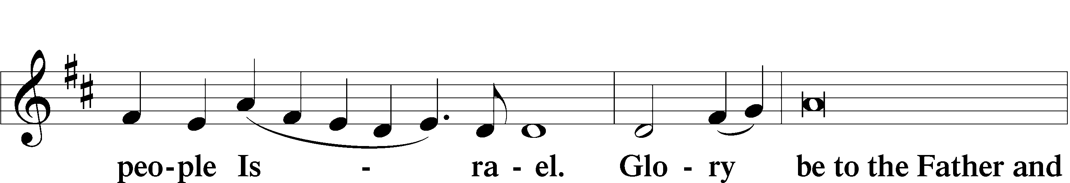
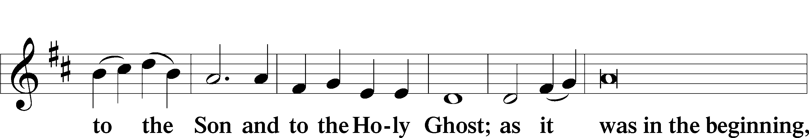
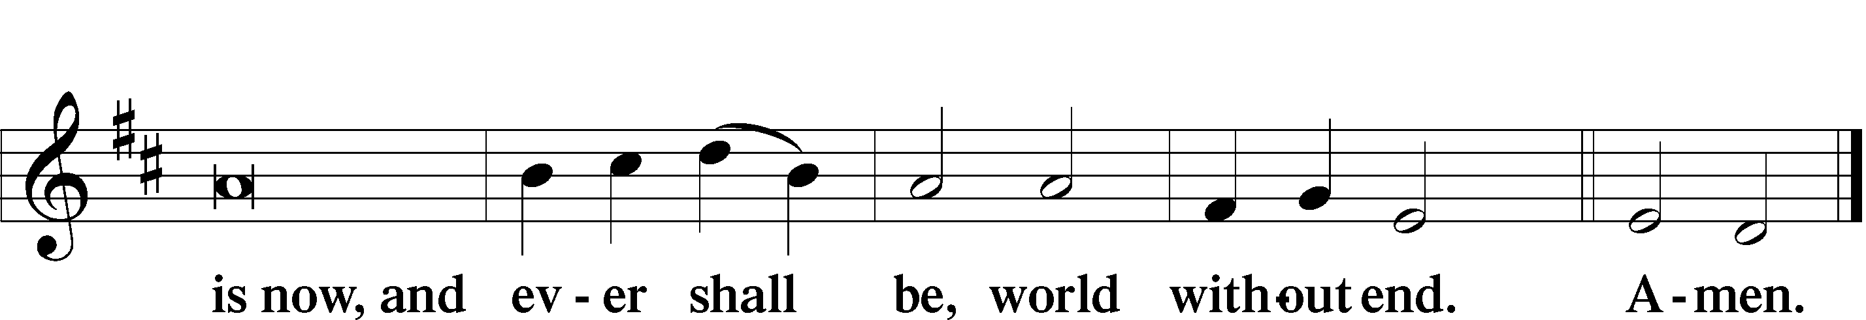

Thanksgiving
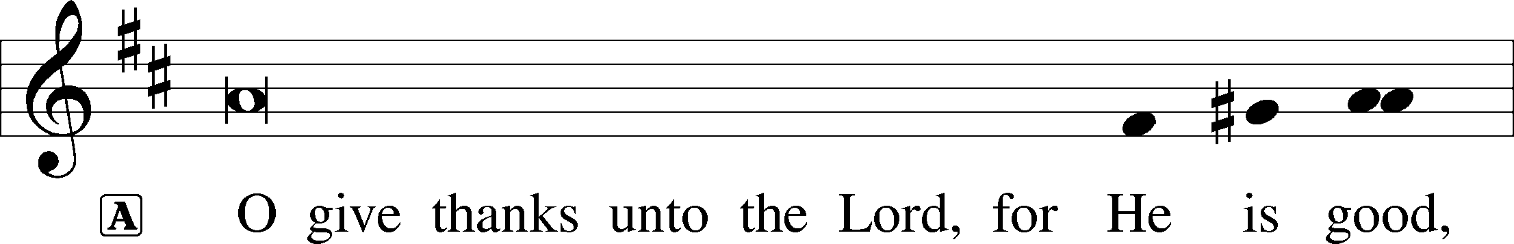
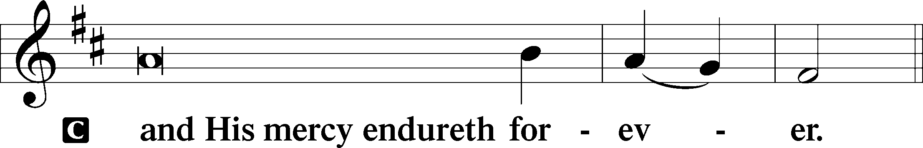

Post-Communion COLLECT
1
2
3
P Let us pray. We give thanks to You, almighty God, that You have refreshed us through this salutary gift, and we implore You that of Your mercy You would strengthen us through the same in faith toward You and fervent love toward one another; through Jesus Christ, Your Son, our Lord, who lives and reigns with You and the Holy Spirit, one God, now and forever.
C Amen.

Salutation
P The Lord be with you.
C And with thy spirit.

Benedicamus
P Bless we the Lord.
C Thanks be to God.

BENEDICTION Numbers 6:24–26
P The Lord bless you and keep you.
The Lord make His face shine on you and be gracious to you.
The Lord look upon you with favor and give you peace.
C Amen.

CLOSING HYMN “Voices Raised to You We Offer” (LSB 795)

Divine Service, Setting Three from Lutheran Service Book. Created by Lutheran Service Builder © 2006 Concordia Publishing House.
All rights reserved. Used by permission.

